**Software Requirements Specification**

**for**

**The Gioi Di Dong, Release 1.0**

**Version 1.0 approved**

**Prepared by Team 3**

**Process Impact**

**3/6/2022**

Table of Contents

**1.****Introduction 1**

1.1 Purpose 1

1.2 Document Conventions 1

1.3 Project Scope and Product Features 1

1.4 References 1

**2.****Overall Description 1**

2.1 Product Perspective 1

2.2 User Classes and Characteristics 2

2.3 Operating Environment 3

2.4 Design and Implementation Constraints 3

2.5 Assumptions and Dependencies 3

**3.****System Features 3**

3.1 Manage an Event 3

3.1.1 Description 3

3.1.2 Functional Requirements 3

3.2 Order Meals from Restaurants 5

3.3 Create, View, Modify, and Delete TBD 5

3.4 Create, View, Modify, and Delete TBD 5

**4.****Data Requirements 6**

4.1 Logical Data Model 6

4.2 Data Dictionary 6

4.3 Reports 9

4.3.1 TBD Report 9

4.4 Data Integrity, Retention, and Disposal 9

**5.****External Interface Requirements 10**

5.1 User Interfaces 10

5.2 Software Interfaces 10

5.3 Hardware Interfaces 10

5.4 Communications Interfaces 10

**6.****Quality Attributes 11**

6.1 Usability Requirements 11

6.2 Performance Requirements 11

6.3 Security Requirements 11

6.4 Safety Requirements 11

6.5 Availability Requirements 11

6.6 Robustness Requirements 11

**Appendix A: Analysis Models 12**

**Revision History**

|  |  |  |  |
| --- | --- | --- | --- |
| **Name** | **Date** | **Reason For Changes** | **Version** |
| Nguyen Le Hoang An | 07/06/2022 | initial draft | 1.0 draft 1 |
| Nguyen Van Sang | 08/06/2022 | Usecase diagram | 1.0 draft 1 |

# **Introduction**

## **Purpose**

This SRS document describes the functional and nonfunctional requirements for software releases of The Gioi Di Dong (TGDD). This document is intended to be used by the members of the project team (Nhom 3) who will research and implement the functioning of the system. This document is intended for both the stakeholders and the developers of the system and will be proposed to the potential clients for its approval

## **Document Conventions**

No special typographical conventions are used in this SRS.

## **Project Scope and Product Features**

This software product will be the website for manager, buyers and collaborators of the mobile store and along with the features that are scheduled for implementation within future releases.

## **Glossary**

|  |  |
| --- | --- |
| **Term** | **Definition** |
| Collaborator | Users could login to update data |
| Customer | Users want to find and buy items |

# **Overall Description**

## **Product Perspective**

End users could be project managers, other project members. There are more than 100 possible users.

*Figure 1 - Context Diagram*

**Figure 1. Context diagram for release 1.0 of the TBD**

## **Functional Requirement Specification**

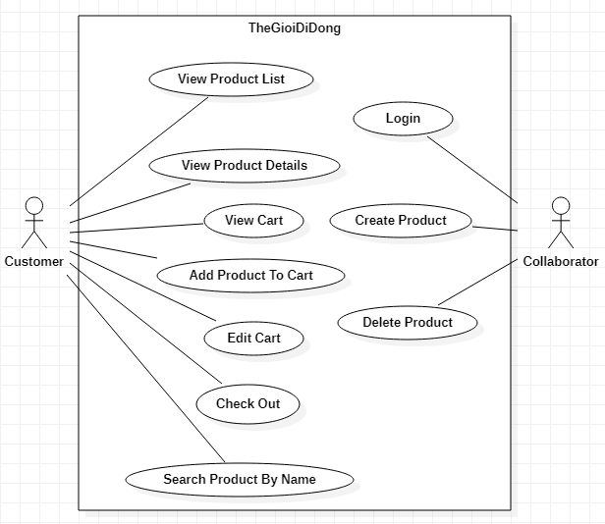

Figure 1 – TheGioiDiDong System Use Case

This section outlines the use cases for each of the active user separately.

### TheGioiDiDong Customer Use Case

#### Use case: Customer Login

**Diagram:**

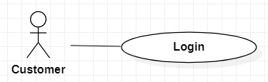

**Brief Description**

The customer accesses the TheGioiDiDong to login.

**Initial Step-By-Step Description**

Before this use case can be initiated, the user has already accessed the login page on TheGioiDiDong website.

1. The customer accesses the login page.
2. The customer fills username/password.
3. The system validates input and response error message if error happened.
4. The system redirect to view products list page if correct username/password.
5. The system allows the user to perform other activities.

#### Use case: Customer View List Products

**Diagram:**

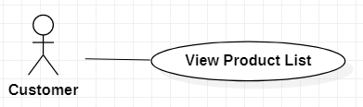

**Brief Description**

The customer accesses the TheGioiDiDong to view list products.

**Initial Step-By-Step Description**

Before this use case can be initiated, the user has already accessed the TheGioiDiDong website with role customer.

1. The customer accesses the home page.
2. The system redirects to list all products.
3. The system allows the user to perform other activities.

#### Use case: Customer View Product Details

**Diagram:**

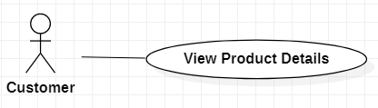

**Brief Description**

The customer accesses the TheGioiDiDong to view product details

**Initial Step-By-Step Description**

Before this use case can be initiated, the user has already accessed the TheGioiDiDong with role customer.

1. The customer accesses the home page.
2. The system redirects to list all products.
3. The customer selects product.
4. The system redirects to product detail page.
5. The system allows the user to perform other activities.

#### Use case: Customer Add product to cart

**Diagram:**

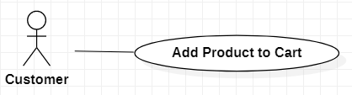

**Brief Description**

The customer accesses the TheGioiDiDong to add product to cart.

**Initial Step-By-Step Description**

Before this use case can be initiated, the user has already accessed the TheGioiDiDong website with role customer.

1. The customer accesses the TheGioiDiDong.
2. The customer clicks button order now on each product (list all products page or detail product page).
3. The system adds selected product to cart.
4. The system allows the user to perform other activities.

#### Use case: Customer View cart

**Diagram:**

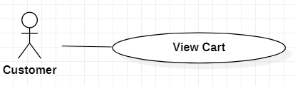

**Brief Description**

The customer accesses the TheGioiDiDong to transfer money to view cart

**Initial Step-By-Step Description**

Before this use case can be initiated, the user has already accessed the TheGioiDiDong with role customer.

1. The customer accesses the home page.
2. The system redirects to list all products.
3. The customer clicks view cart on top right.
4. The system redirects to cart page.
5. The system allows the user to perform other activities.

#### Use case: Customer Edit cart

**Diagram:**

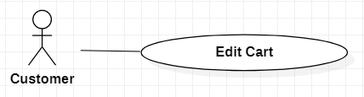

**Brief Description**

The customer accesses the TheGioiDiDong to edit cart.

**Initial Step-By-Step Description**

Before this use case can be initiated, the user has already accessed the TheGioiDiDong website with role customer.

1. The customer accesses the home page.
2. The system redirects to list all products.
3. The customer clicks view cart on top right.
4. The system redirects to cart page.
5. The system shows all selected products.
6. The customer can removes each cart item or clears all cart.
7. The system allows the user to perform other activities.

Use case: Customer Check Out

**Diagram:**

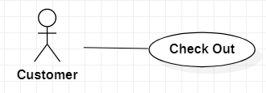

**Brief Description**

The customer accesses the TheGioiDiDong to check out.

**Initial Step-By-Step Description**

Before this use case can be initiated, the user has already accessed the TheGioiDiDong website with role customer.

1. The customer accesses the home page.
2. The system redirects to list all products.
3. The customer clicks view cart on top right.
4. The system redirects to cart page.
5. The customer clicks check out.
6. The system will ask to fill in customer information
7. The system allows the user to perform other activities.

Use case: Customer Search Product by name

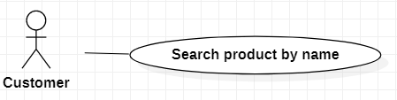

**Brief Description**

The customer accesses the TheGioiDiDong to search product by name.

**Initial Step-By-Step Description**

Before this use case can be initiated, the user has already accessed the TheGioiDiDong website with role customer.

1. The customer accesses the home page.
2. The system redirects to list all products.
3. Customers type the product name in the search box at the top of the page
4. The system redirects to the page containing the relevant product.
5. The system allows the user to perform other activities.

### 2.2.2 TheGioiDiDong Collaborator Use Case

#### Use case: Collaborator Login

**Diagram:**

#### 

**Brief Description**

The admin accesses the TheGioiDiDong to login.

**Initial Step-By-Step Description**

Before this use case can be initiated, the user has already accessed the login page on TheGioiDiDong website.

1. The collaborator accesses the login page.
2. The collaborator fills username/password.
3. The system validates input and response error message if error happened.
4. The system redirect to view products list page if correct username/password.
5. The system allows the user to perform create new products.

#### Use case: Collaborator add a new product

**Diagram:**

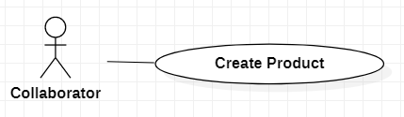

**Brief Description**

The collaborator accesses the TheGioiDiDong to add a new product.

**Initial Step-By-Step Description**

Before this use case can be initiated, the user has already accessed the TheGioiDiDong website with role collaborator.

1. The collaborator accesses to add product page.
2. The collaborator fills new product information and click add product.
3. The system insert new product to database and clear form.
4. The system allows the collaborator to perform other activities.

#### Use case: Collaborator delete product

**Diagram:**

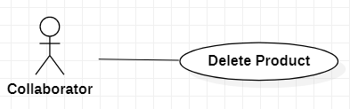

**Brief Description**

The collaborator accesses the TheGioiDiDong to delete product.

**Initial Step-By-Step Description**

Before this use case can be initiated, the user has already accessed the TheGioiDiDong website with role collaborator.

1. The collaborator accesses to the home page.
2. The collaborator can choose to delete each product.
3. The product will be changed to status = false and hidden in the home page.
4. The system allows the collaborator to perform other activities.

## 2.3 User Characteristics

TBD

## 2.4 Non-Functional Requirements

TBD

# 3.0. Requirements Specification

## 3.1 External Interface Requirements

TBD

## 3.2 Functional Requirements

The Logical Structure of the Data is contained in Section 3.3.1.

### Customer View Product List

|  |  |
| --- | --- |
| **Use Case Name** | Customer View Product List |
| **XRef** | Section 2.2.1, Customer View Product List |
| **Trigger** | The user accesses the TheGioiDiDong website |
| **Precondition** | None |
| **Basic Path** | 1. The customer accesses the home page. 2. The system redirects to list all products. 3. The system allows the user to perform other activities. |
| **Alternative Paths** | None |
| **Postcondition** | None |
| **Exception Paths** | None |
| **Other** | None |

### Customer View Product Details

|  |  |
| --- | --- |
| **Use Case Name** | Customer View Product Details |
| **XRef** | Section 2.2.1, Customer View Product Details |
| **Trigger** | The user accesses the TheGioiDiDong website |
| **Precondition** | The customer selects a product to view detail. |
| **Basic Path** | 1. The customer accesses the home page. 2. The system redirects to list all products. 3. The customer selects product. 4. The system redirects to product detail page. 5. The system allows the user to perform other activities. |
| **Alternative Paths** | None |
| **Postcondition** | None |
| **Exception Paths** | None |
| **Other** | None |

### Customer Add product to cart

|  |  |
| --- | --- |
| **Use Case Name** | Customer Add product to cart |
| **XRef** | Section 2.2.1, Customer Add product to cart |
| **Trigger** | The user accesses the TheGioiDiDong website |
| **Precondition** | The system exist product |
| **Basic Path** | 1. The customer accesses the TheGioiDiDong. 2. The customer clicks button order now on each product (list all products page or detail product page). 3. The system adds selected product to cart. 4. The system allows the user to perform other activities. |
| **Alternative Paths** | None |
| **Postcondition** | The system shows success message |
| **Exception Paths** | None |
| **Other** | None |

### Customer View cart

|  |  |
| --- | --- |
| **Use Case Name** | Customer View cart |
| **XRef** | Section 2.2.1, Customer View cart |
| **Trigger** | The user accesses the TheGioiDiDong website |
| **Precondition** | None |
| **Basic Path** | 1. The customer accesses the home page. 2. The system redirects to list all products. 3. The customer clicks view cart on top right. 4. The system redirects to cart page. 5. The system allows the user to perform other activities. |
| **Alternative Paths** | None |
| **Postcondition** | None |
| **Exception Paths** | None |
| **Other** | None |

### Customer Edit cart

|  |  |
| --- | --- |
| **Use Case Name** | Customer Edit cart |
| **XRef** | Section 2.2.1, Customer Edit cart |
| **Trigger** | The user accesses the TheGioiDiDong website |
| **Precondition** | Exist products on cart |
| **Basic Path** | 1. The customer accesses the home page. 2. The system redirects to list all products. 3. The customer clicks view cart on top right. 4. The system redirects to cart page. 5. The system shows all selected products. 6. The customer can removes each cart item or clears all cart. 7. The system allows the user to perform other activities |
| **Alternative Paths** | None |
| **Postcondition** | None |
| **Exception Paths** | None |
| **Other** | None |

### Customer Check out

|  |  |
| --- | --- |
| **Use Case Name** | Customer Check out |
| **XRef** | Section 2.2.1, Customer Check out |
| **Trigger** | The user accesses the TheGioiDiDong website |
| **Precondition** | Exist products on cart |
| **Basic Path** | 1. The customer accesses the home page.  2. The system redirects to list all products.  3. The customer clicks view cart on top right.  4. The system redirects to cart page.  5. The customer clicks check out.  6. The system will ask to fill in customer information  7. The system allows the user to perform other activities. |
| **Alternative Paths** | None |
| **Postcondition** | None |
| **Exception Paths** | None |
| **Other** | None |

### Customer Search product by name

|  |  |
| --- | --- |
| **Use Case Name** | Customer Search product by name |
| **XRef** | Section 2.2.1, Customer Search product by name |
| **Trigger** | The user accesses the TheGioiDiDong website |
| **Precondition** | None |
| **Basic Path** | 1. The customer accesses the home page.  2. The system redirects to list all products.  3. Customers type the product name in the search box at the top of the page  4. The system redirects to the page containing the relevant product.  5. The system allows the user to perform other activities. |
| **Alternative Paths** | None |
| **Postcondition** | None |
| **Exception Paths** | None |
| **Other** | None |

### Collaborator Login

|  |  |
| --- | --- |
| **Use Case Name** | Collaborator login |
| **XRef** | Section 2.2.1, Collaborator login |
| **Trigger** | The user accesses the login page of TheGioiDiDong website |
| **Precondition** | The login form display |
| **Basic Path** | 1. The collaborator accesses the login page. 2. The collaborator fills username/password. 3. The system validates input and response error message if error happened. 4. The system redirect to add product page if correct username/password. 5. The system allows the user to perform create new products. |
| **Alternative Paths** | None |
| **Postcondition** | None |
| **Exception Paths** | None |
| **Other** | None |

### Collaborator add new product

|  |  |
| --- | --- |
| **Use Case Name** | Collaborator add new product |
| **XRef** | Section 2.2.2, Collaborator add new product |
| **Trigger** | The collaborator accesses the TheGioiDiDong website |
| **Precondition** | None |
| **Basic Path** | 1. The collaborator accesses to add product page. 2. The collaborator fills new product information and click add product. 3. The system insert new product to database and clear form. 4. The system allows the collaborator to perform other activities. |
| **Alternative Paths** | None |
| **Postcondition** | None |
| **Exception Paths** | None |
| **Other** | None |

### Collaborator Delete Product

|  |  |
| --- | --- |
| **Use Case Name** | Admin delete product |
| **XRef** | Section 2.2.2, Admin delete product |
| **Trigger** | The collaborator accesses the TheGioiDiDong website |
| **Precondition** | None |
| **Basic Path** | 1. The collaborator accesses to the home page.  2. The collaborator can choose to delete each product.  3. The product will be changed to status = false and hidden in the home page.  4. The system allows the collaborator to perform other activities. |
| **Alternative Paths** | None |
| **Postcondition** | None |
| **Exception Paths** | None |
| **Other** | None |

## 3.3 Detailed Non-Functional Requirements

### 3.3.1 Logical Structure of the Data

The logical structure of the data to be stored on the system is given below:

Figure 2 - Logical Structure of the Mobile Store

### 3.3.2 Security

TBD

### Performance

TBD